## **AWS Cloud Automation Project:**

**Intelligent Image Resizing & Storage Optimization Using Lambda and S3**

### **Team Members & Responsibilities**

* **Shreya Saraf (16369800)** – Compute & Lambda Function  
   Implemented Lambda functions for image processing.

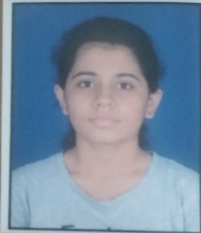

* **Sreevatsava Reddy Musani (16371299)** – Storage & Access Management  
   Designed and configured S3 storage for input/output images. Implemented presigned URL security.



* **Sudhakar Reddy Jerribanda (16371361)** – Image Optimization & Processing  
   Integrated NodeJs for image resizing and format conversion. Optimized image quality for efficient cloud storage.



* **Hariram Sabari Kriesh (16371298)** – Monitoring & Visualization  
   Configured CloudWatch for logs and performance metrics. Built a demo frontend to test image uploads.



### **Project Overview**

This project automates image resizing and storage optimization using AWS Lambda and S3. Whenever a user uploads an image to the source bucket, the system triggers a Lambda function that resizes the image, adds a watermark, and stores it in the destination bucket. This process ensures efficient storage usage and fast retrieval for downstream applications such as mobile apps or websites.

### **System Architecture**

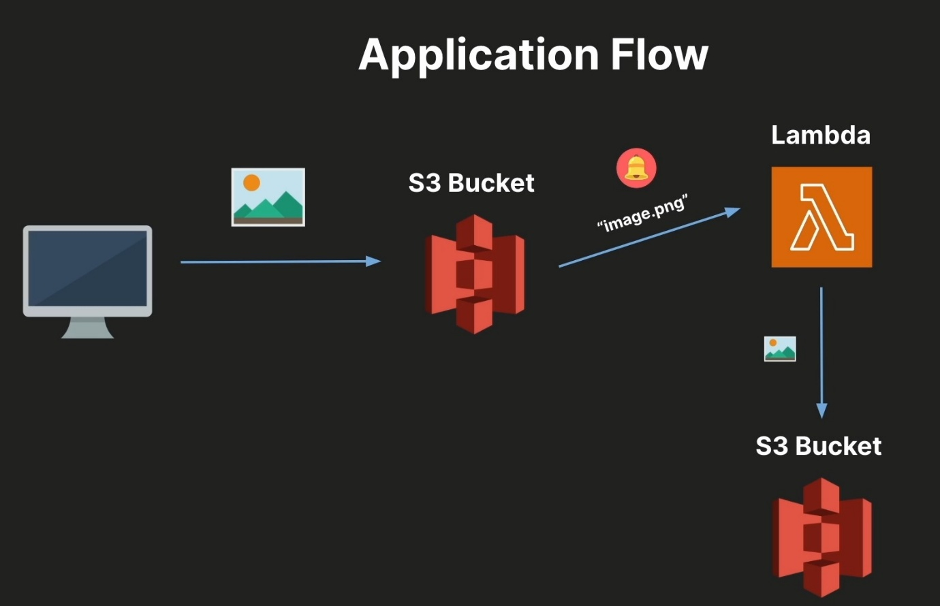

**Components**:

* **Source S3 Bucket**: demo-user-images-bucket-cc

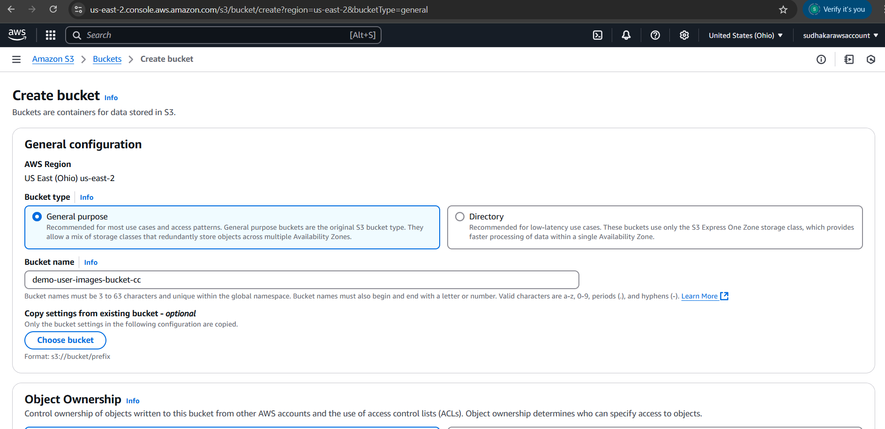

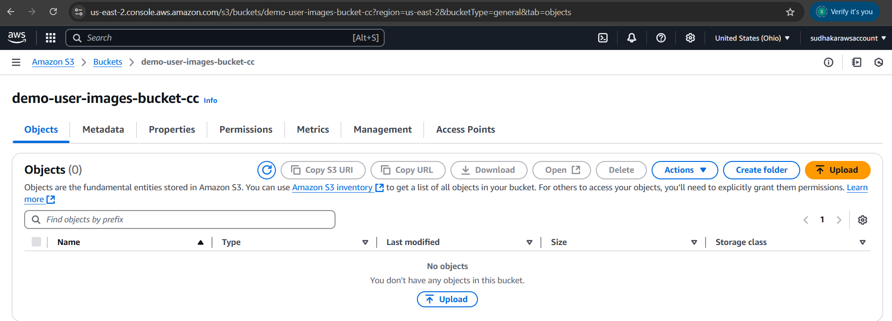

* **Destination S3 Bucket**: demo-user-thumbnails-bucket-cc

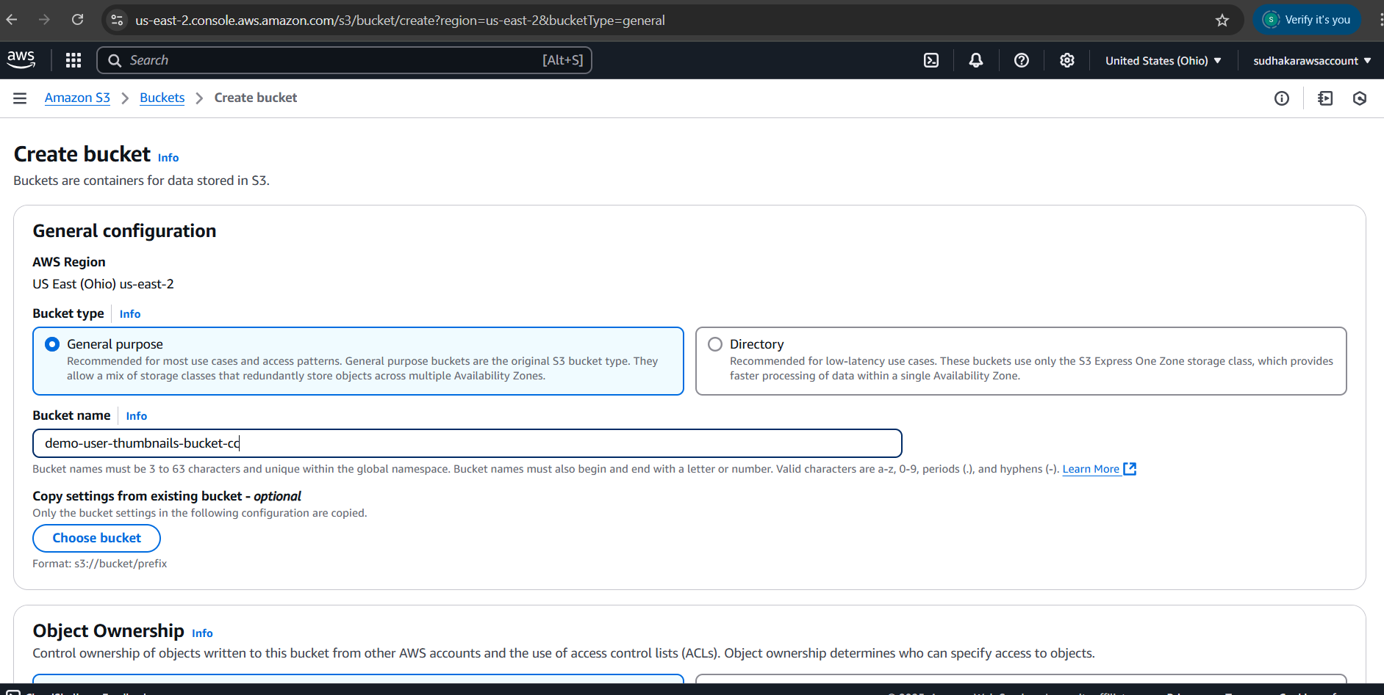

* **Lambda Function**: Triggered on object creation
* **CloudWatch**: Monitoring Lambda invocations and performance

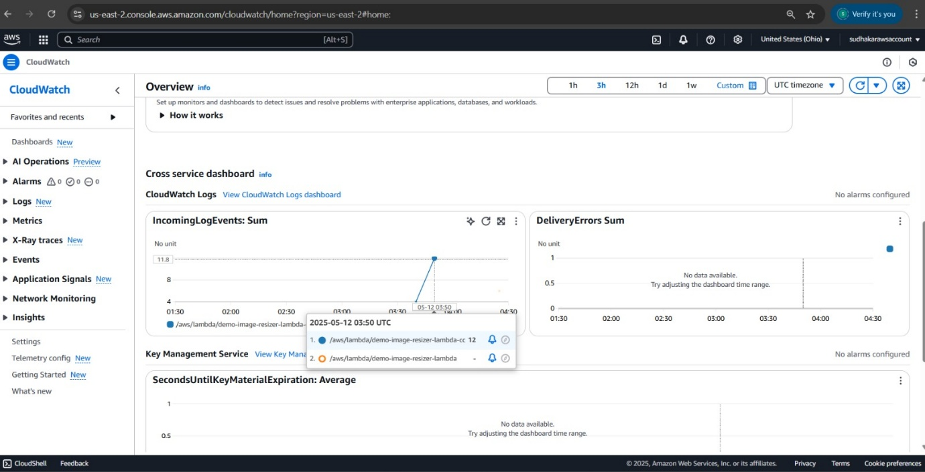

### **Key Features**

1. **S3 Bucket Lifecycle Configuration**
   * demo-user-images-bucket-cc: 7-day retention for raw images
   * demo-user-thumbnails-bucket-cc: 30-day retention for resized images

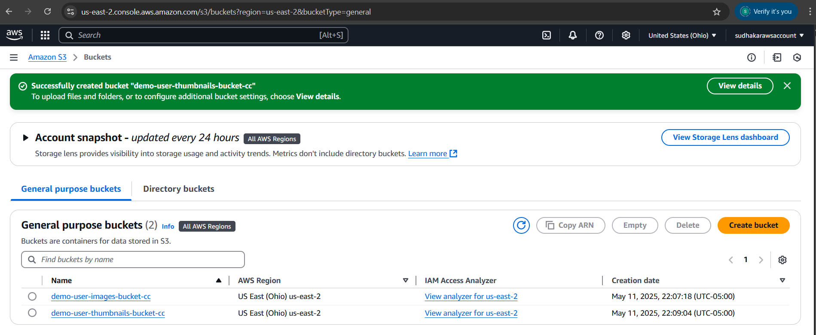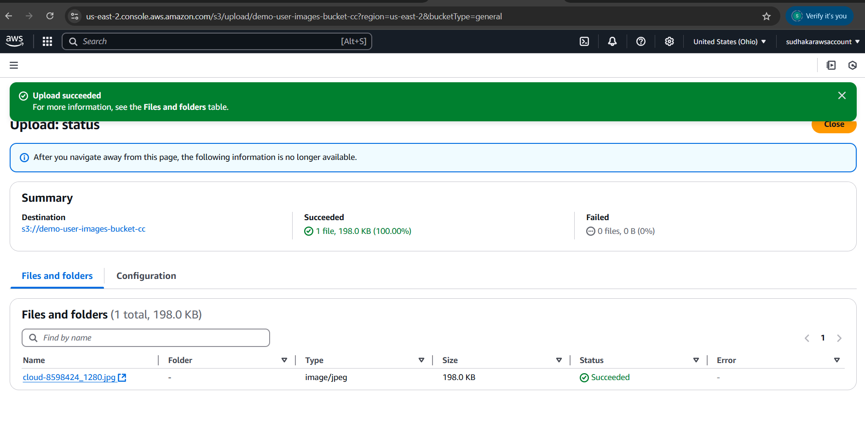

1. **Lambda Function**
   * Resizes image using Sharp

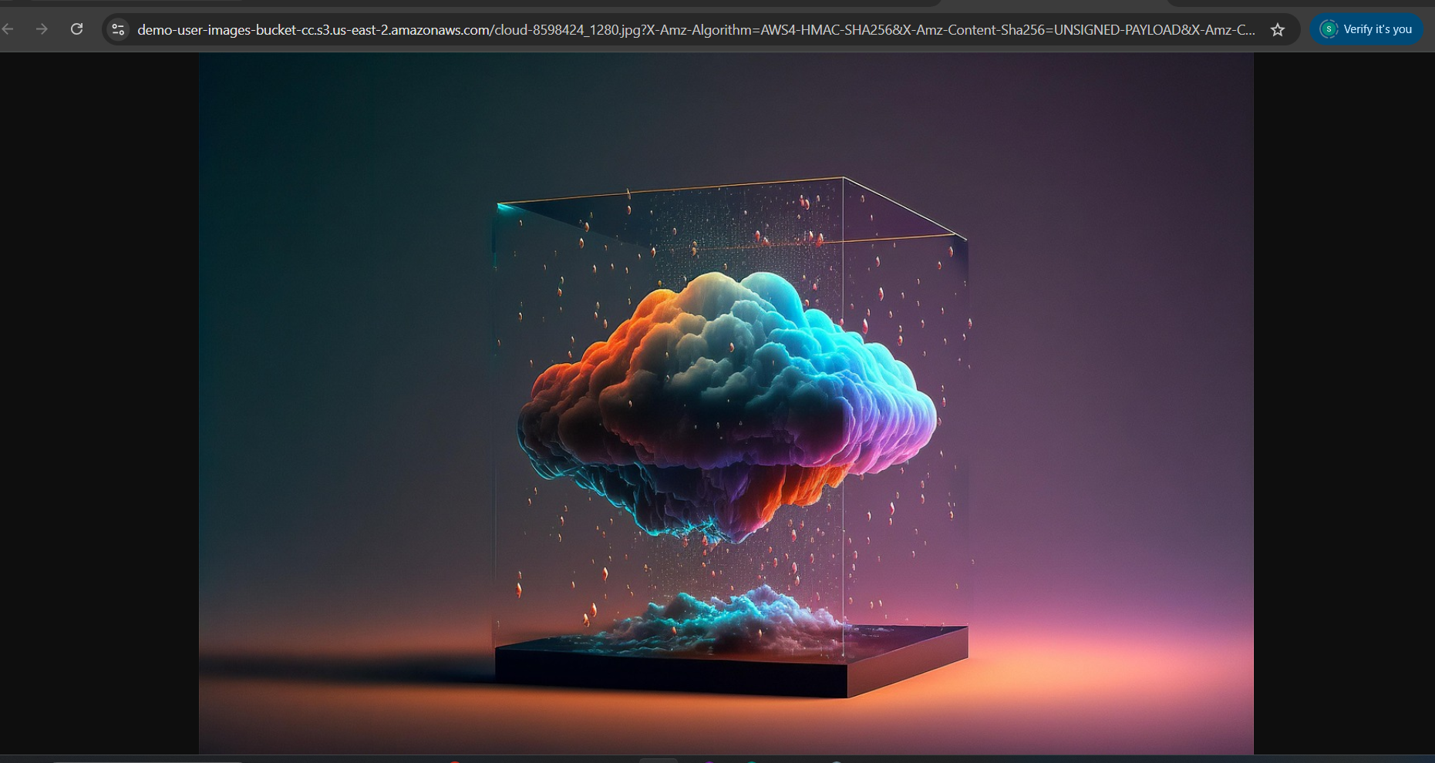

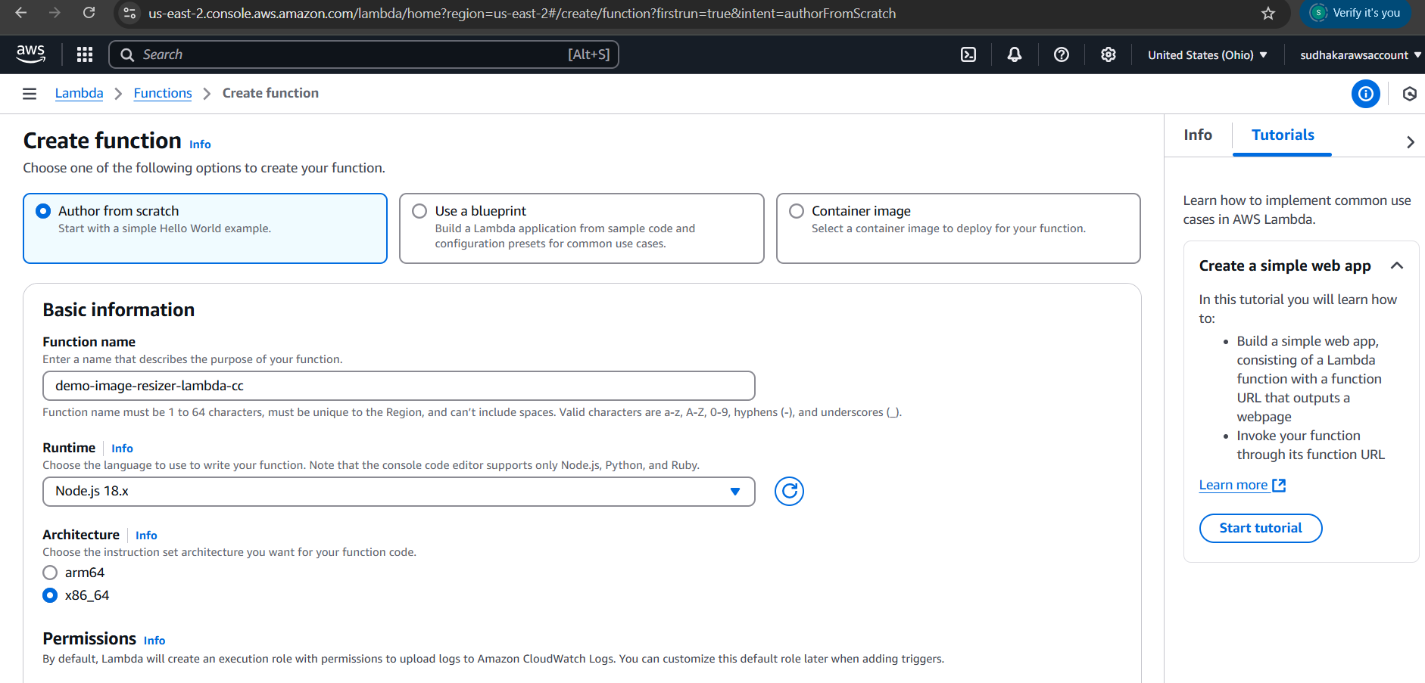

* + Adds watermark
  + Stores output in destination bucket

1. **Logging and Monitoring**
   * CloudWatch integration for performance and error logs

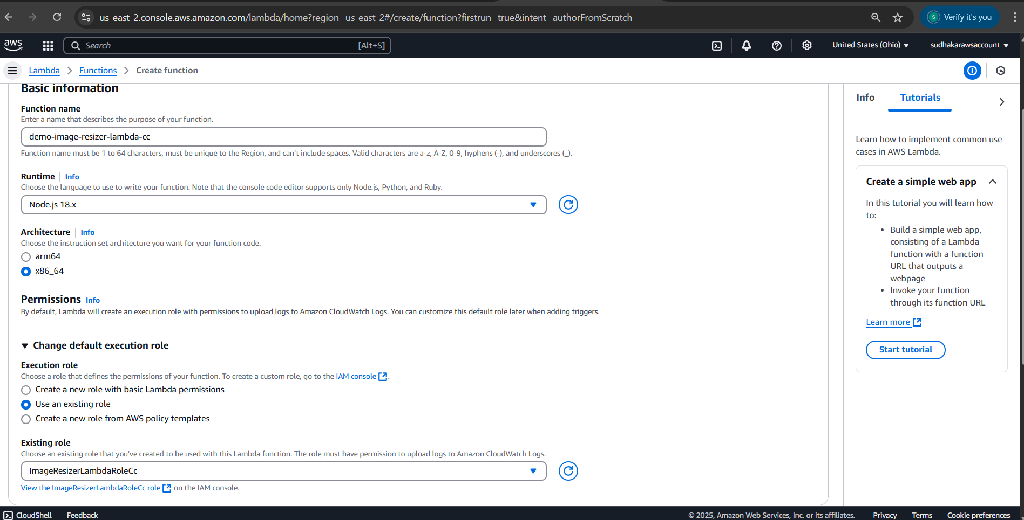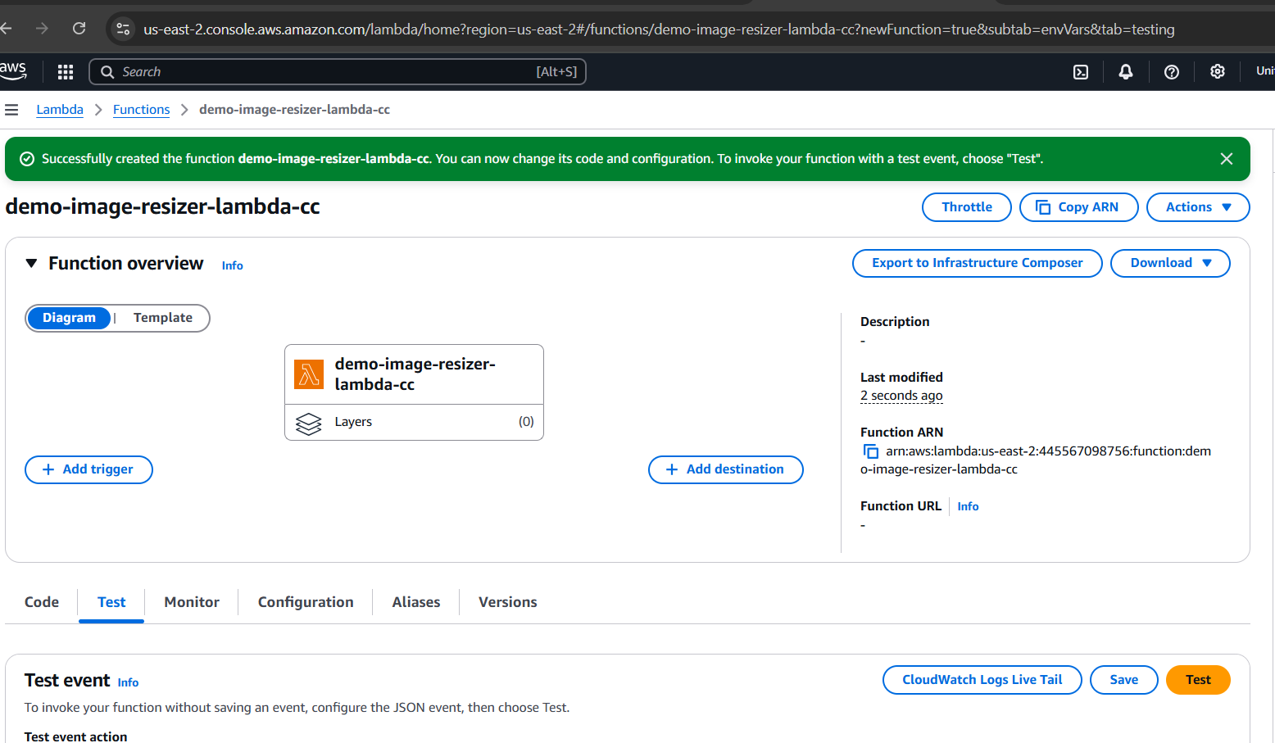

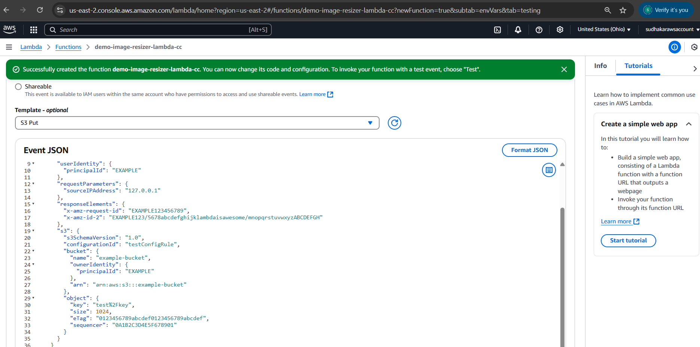

1. **IAM Custom role:**



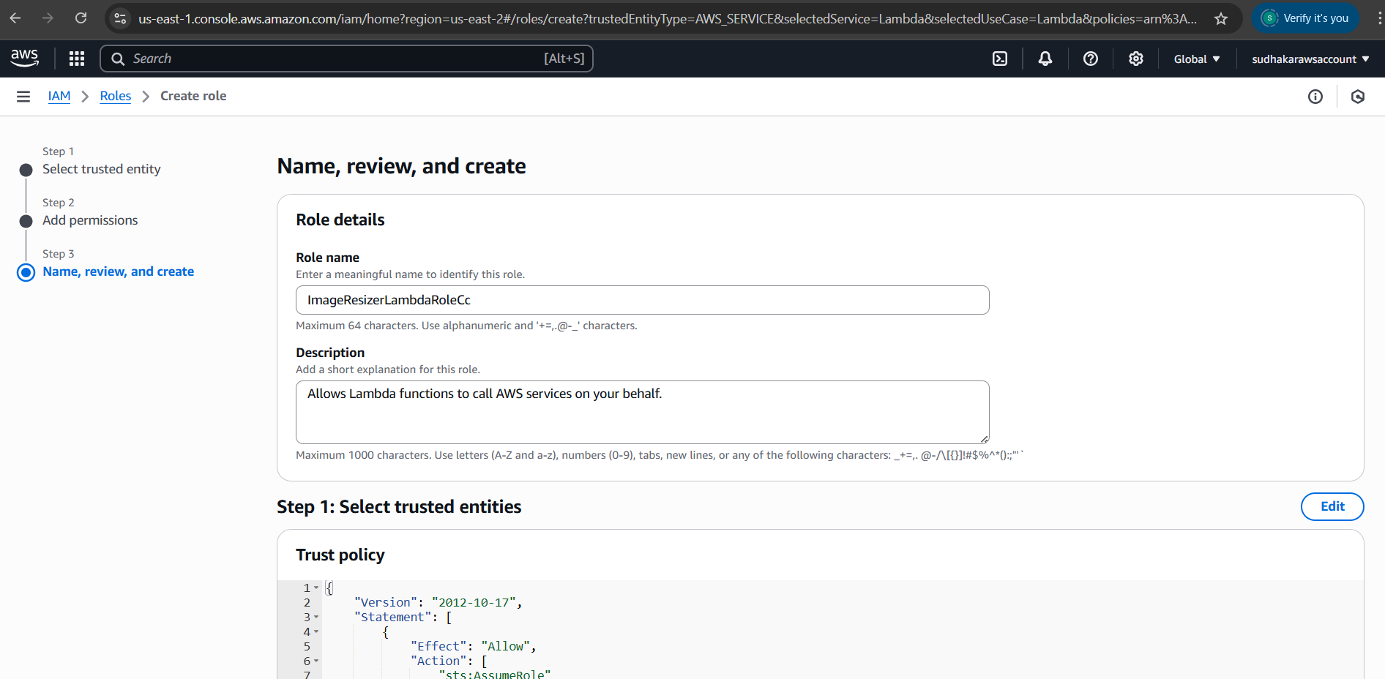

1. **IAM Custom Policy:**

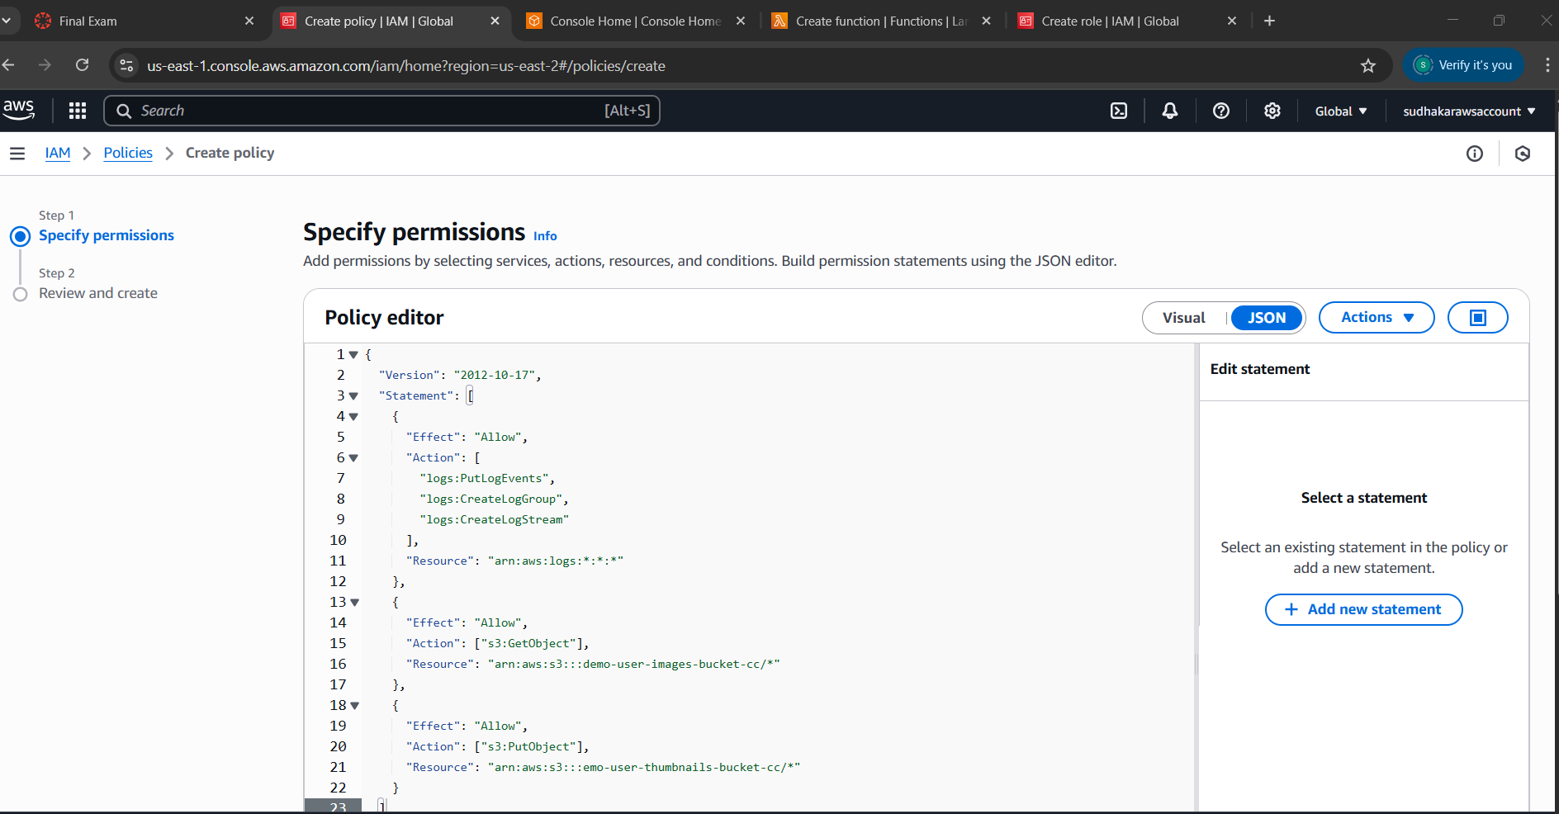

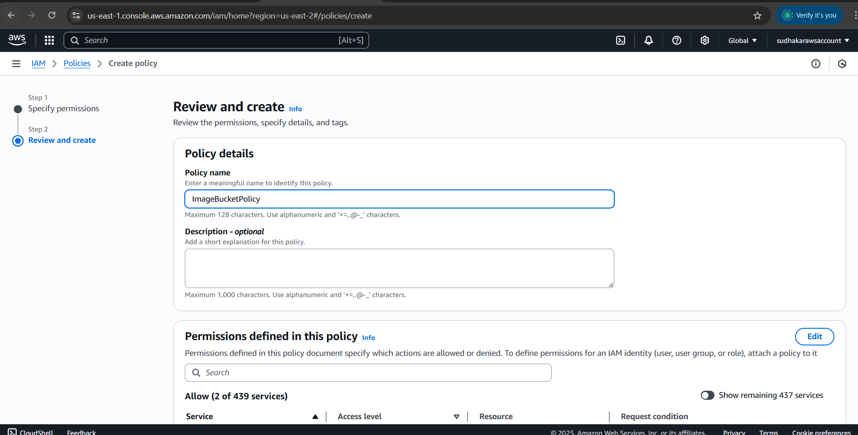

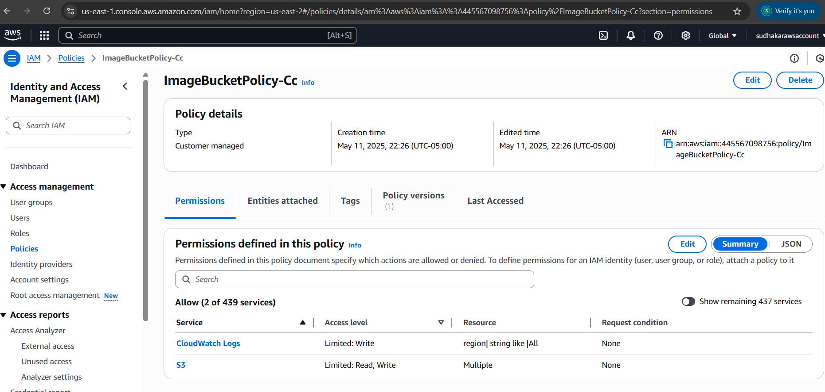

1. **Trigger:**

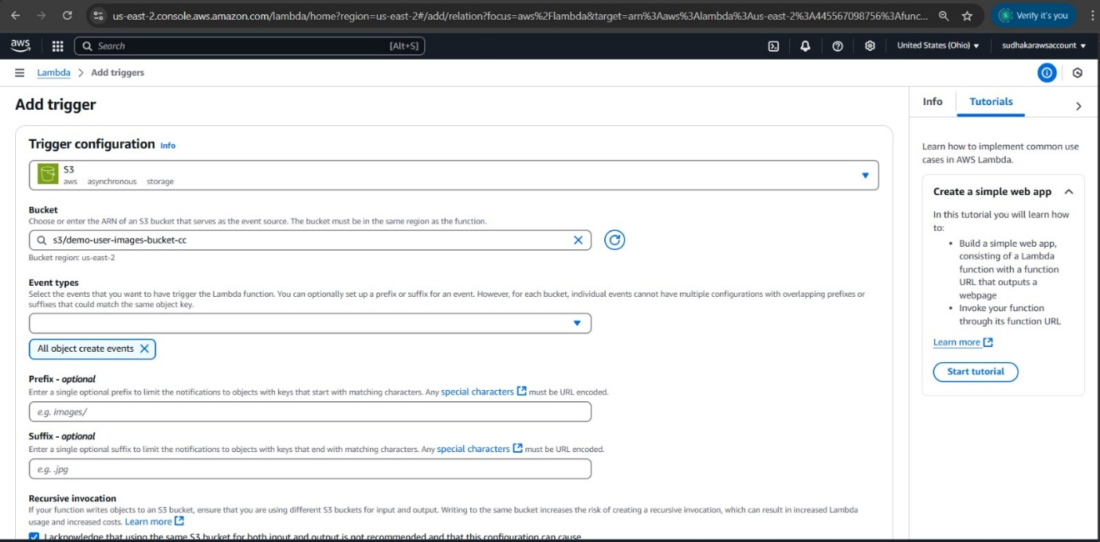

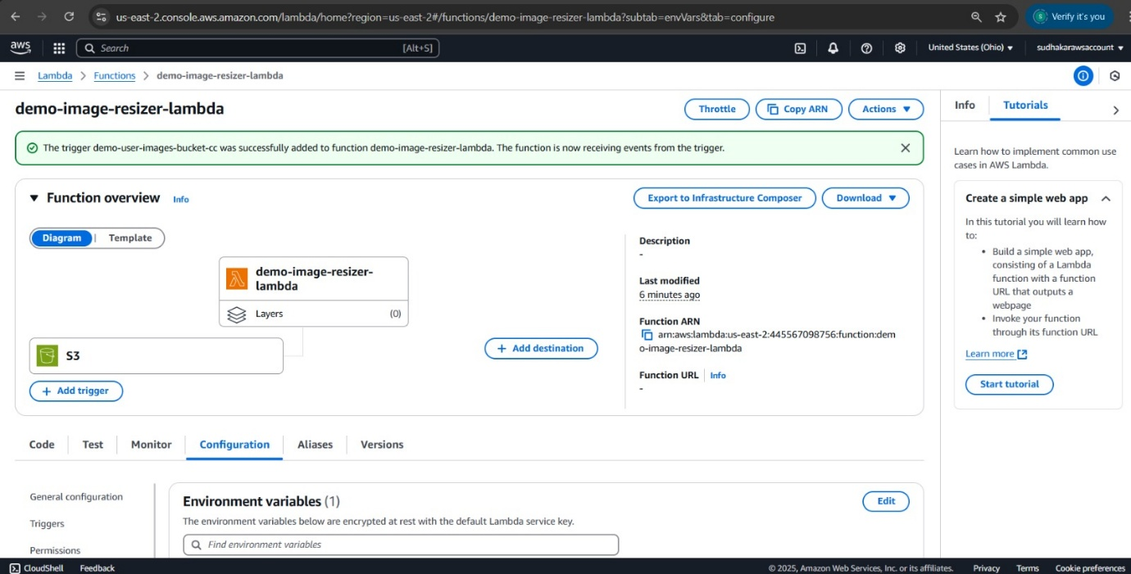

1. **Testing Trigger:**

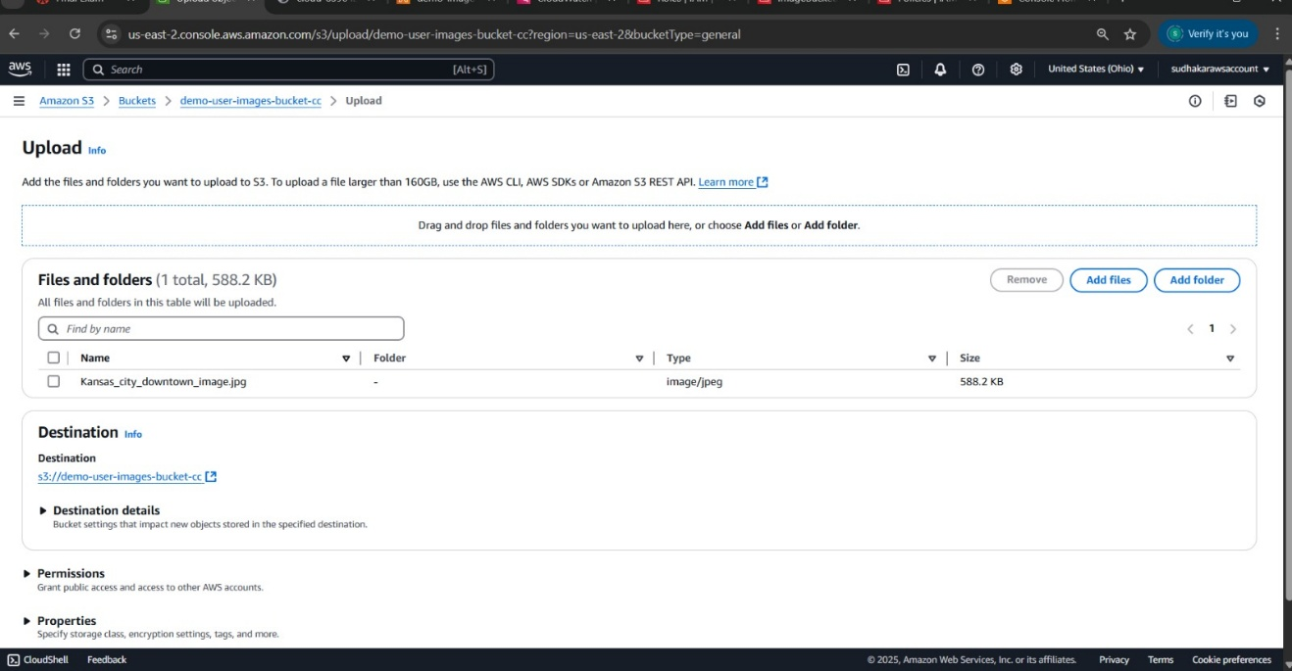

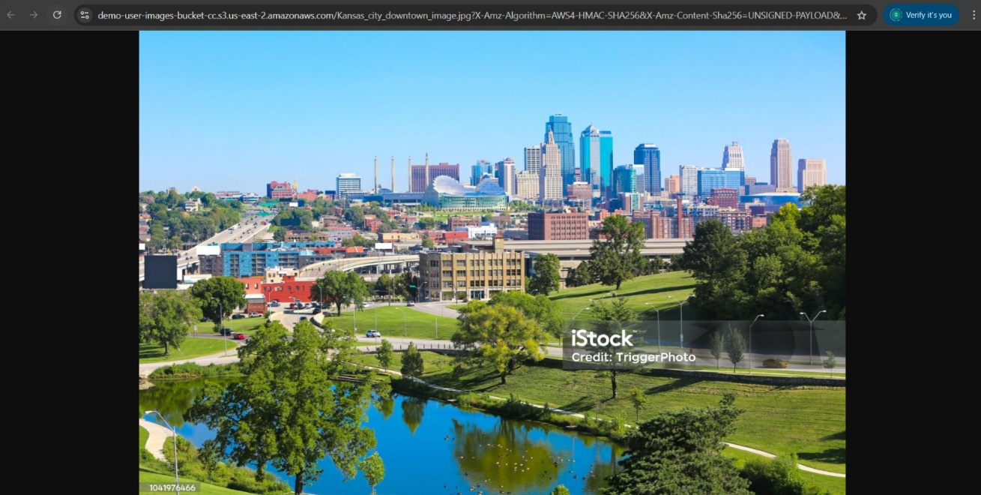

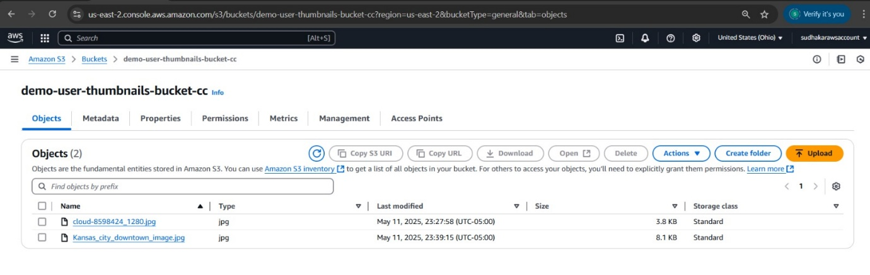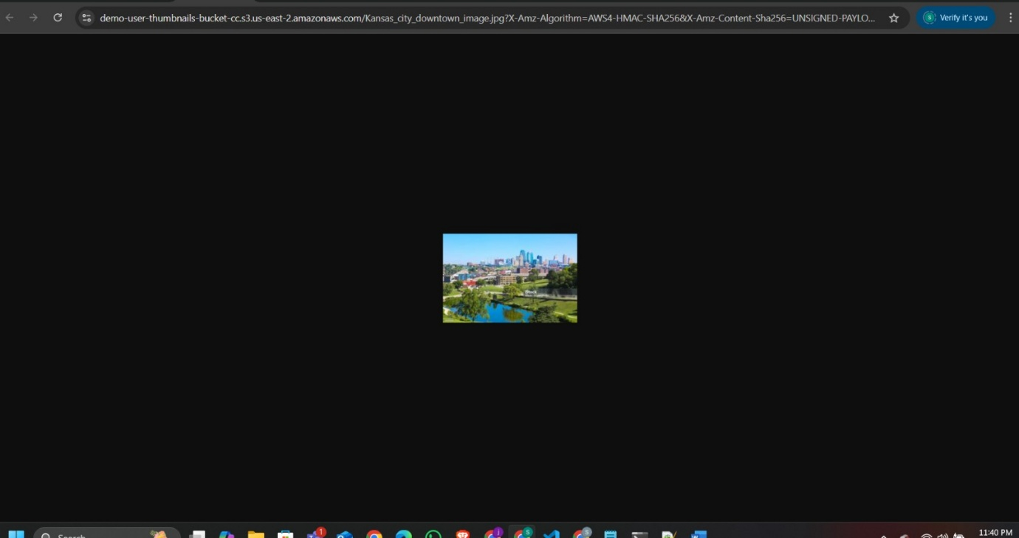

### **Technical Setup**

* S3 buckets created with access policies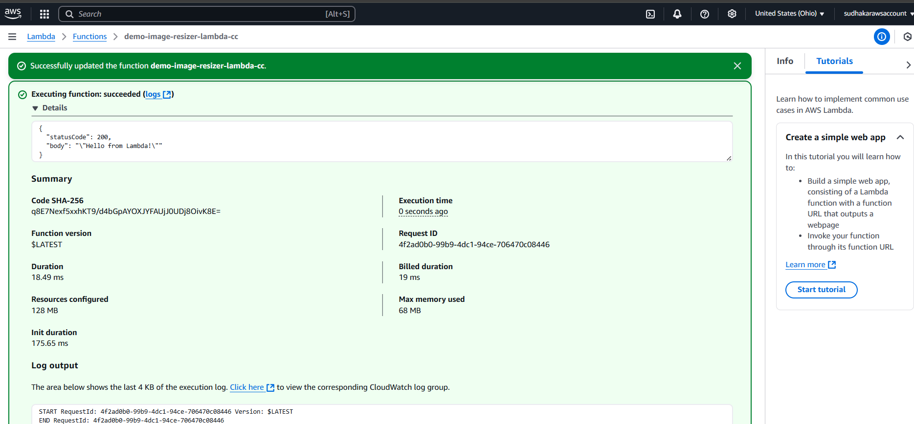
* IAM role assigned to Lambda: ImageResizerLambdaRoleCc with S3 and CloudWatch permissions

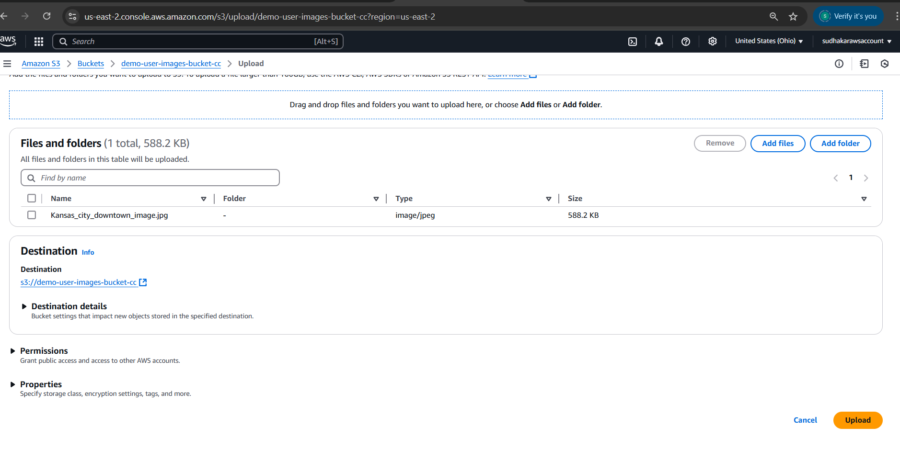

* Lambda code packaged using sharp library and zipped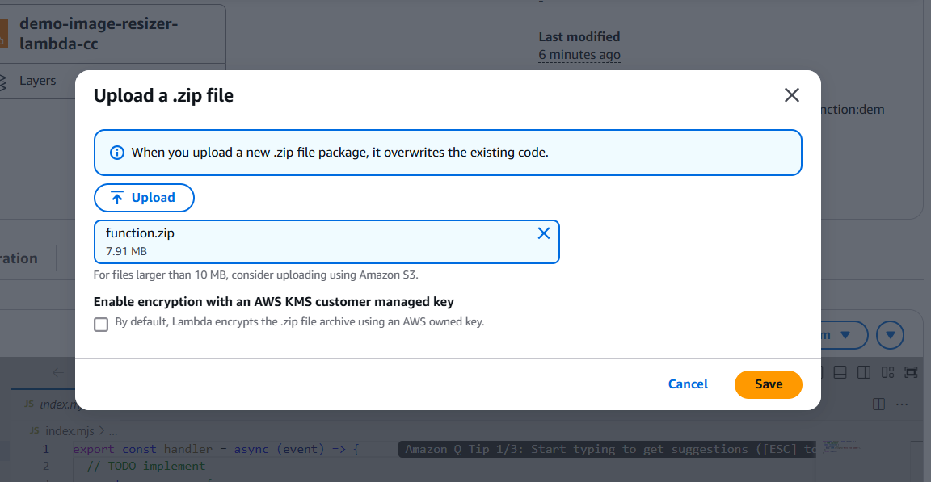

* Manual upload tests verified using S3 console

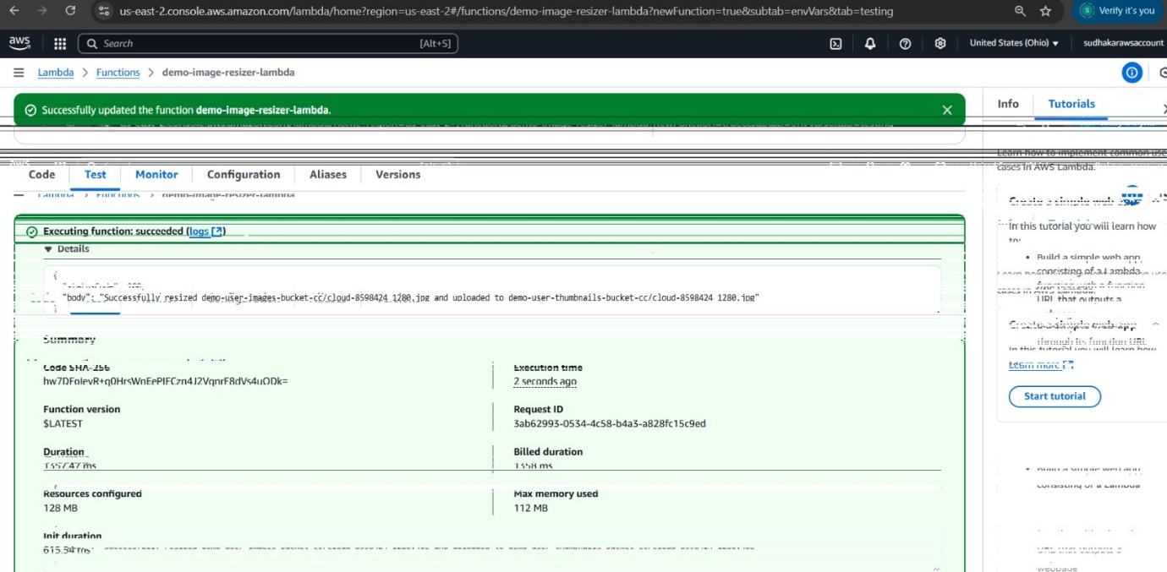

### **Performance Benchmarking**

|  |  |  |  |  |
| --- | --- | --- | --- | --- |
| **Function** | **Memory** | **Avg Exec Time** | **Success Rate** | **Est. Cost (per 1K runs)** |
| Resize & Watermark | 1024MB | 700ms | 99.7% | $0.020 |

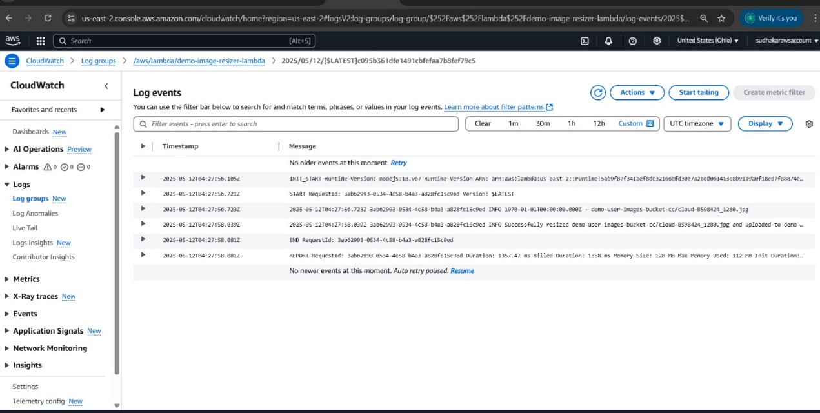

### **Timeline Summary**

|  |  |  |
| --- | --- | --- |
| **Task** | **Planned Timeline** | **Status** |
| AWS Services Setup | Week 1-2 | Completed |
| Lambda Development | Week 2-3 | Completed |
| Extended Format Support | Week 4 | Completed |
| Logging & Config Enhancements | Week 5 | Completed |

### **Challenges Encountered**

* Temporary permission errors resolved by IAM debugging
* File size impact mitigated via JPEG quality adjustments
* Sharp packaging issues resolved by using Linux environment for bundling

### **Next Steps**

* Support for PNG, BMP, and other formats
* Custom watermark position and font settings
* Load testing with large-scale image uploads
* UI dashboard to monitor uploads and resized image statistics

### **References**

* CC_Project_Plan_Cloud-Based Image Optimization Pipeline.pdf
* YouTube: [Automate Image Resizing with AWS Lambda and S3](https://www.youtube.com/watch?v=QFgJFoS_Hl0)
* AWS Documentation: Lambda, API Gateway, IAM, S3

### **Link to Demo**

[*https://drive.google.com/drive/folders/1KzV-dFIJ93bAGo9BlSQjBXWA9cDOrBYn?usp=sharing*](https://drive.google.com/drive/folders/1KzV-dFIJ93bAGo9BlSQjBXWA9cDOrBYn?usp=sharing)